Assignment 2
Assignment 1

Student Name: [Your Name]
Student ID: [Your ID]
Date: November 01, 2025

Data preparation & Overview

1. Load the generated dataset and show the first 10 rows.
The dataset was created by the provided synthetic data generation code. Here are the first 10 rows of the dataset.
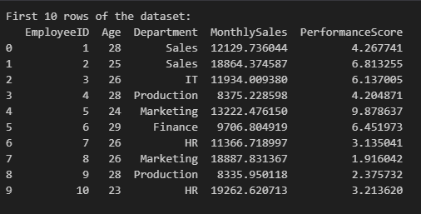

2. Provide summary info

After doing an analyze about the generated synthetic dataset, we can get a overall idea about the dataset
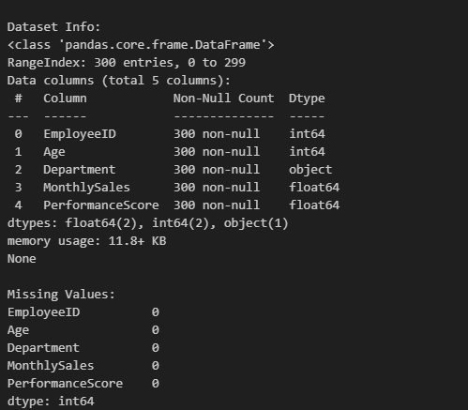

3. Compute and display basic summary statistics for Age, MonthlySales, and PerformanceScore.
Calculations for the statistics are,

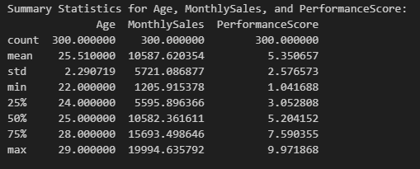

B. Demographic & department analysis

4. Age distribution
Age distribution is uniforms from 22 to29, mean ~25.51, MEDIAN25 and std ~2.29. no outliers

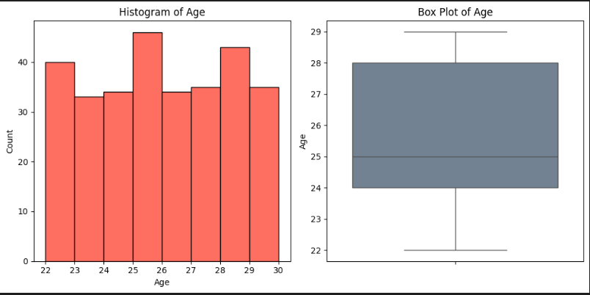

5. Department distribution
Number of employees in each department as follows
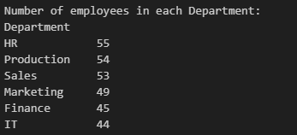

I we make a chart from it, it is the
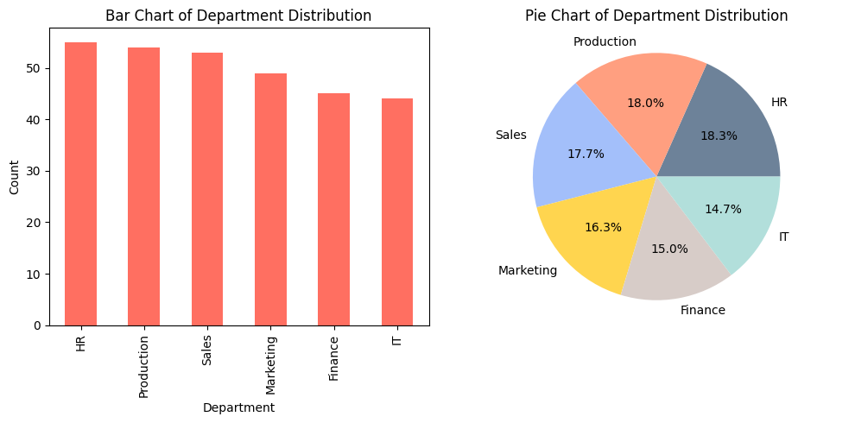

6. Age by department
Box plot for the age distribution by the age as below
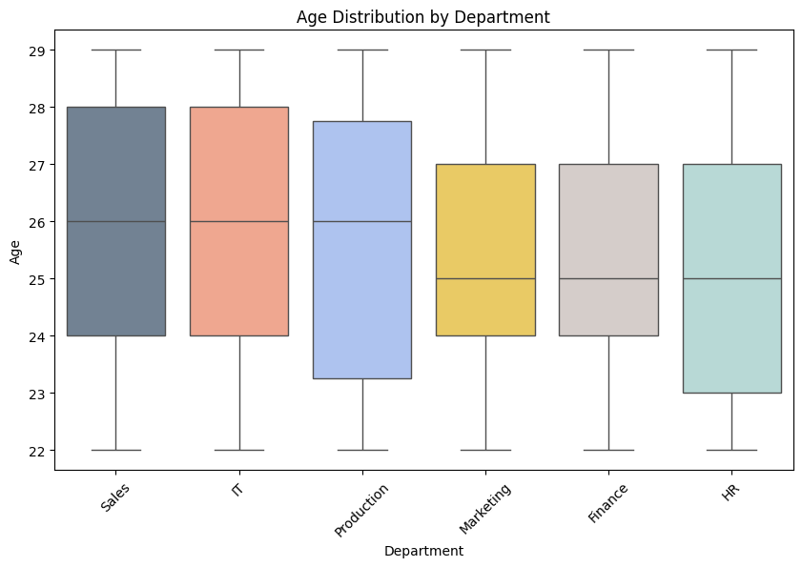
The age range for all departments is between 22 and 29, with medians hovering around 25-26. It consists of the synthetic dataset uniform distribution. (mean ~25.5, std ~2.29), There are no significant outliers or extreme variations in the box plot.
As conclusion, no department is noticeable as younger or older. The age distributions are comparable across all departments, with similar medians, IQRs and overall ranges.

C. Sales & Performance Analysis

7. Monthly sales distribution
The monthly sales data follows a uniform distribution. Sales are spread fair evenly across the range, without concentration around any values.
For the distribution histogram as follows
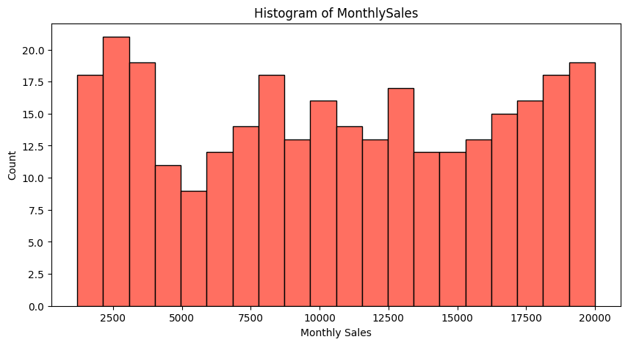

- Mean of MonthlySales: 10587.62
- Median of MonthlySales: 10582.36
- Skewness of MonthlySales: -0.01
- Distribution is uniform from ~1000 to ~20000, with no significant skewness (skew ~0.01). Log transformation not required.

8. Performance score distribution

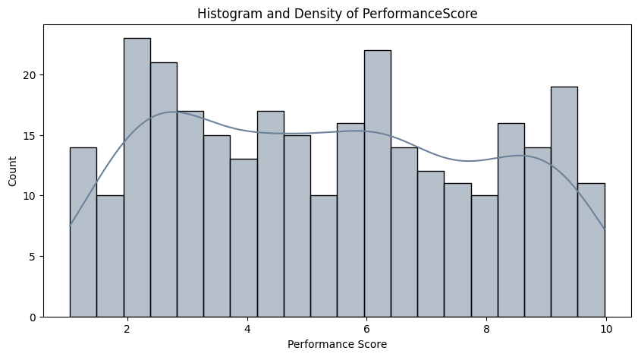
Performance Score Summary: Mean 5.35, std 2.58, min 1.04, max 9.97, median 5.20.
- The histogram and density curve showing that the distribution is fairly uniform across the range 1–10, with mild fluctuations.
- There’s no strong skewness; scores are spread relatively evenly.
- Slight peaks are visible around scores 2–3, 6, and 9, but no single dominant mode.
- The mean and median are close, confirming near-symmetry.

9. Relationship between MonthlySales and PerformanceScore
After creating scatter plot between the MonthlySales and PerformanceScore it as below
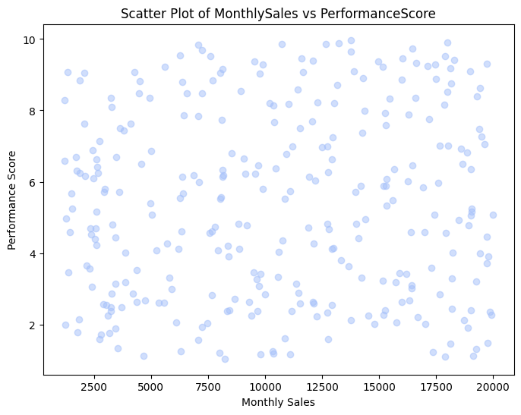

Pearson Correlation Coefficient: 0.0654
There is no significant relationship between the Monthly sales and the performance score. Higher sales are not strongly associated with higher performance scores; relationship is negligible.

10. Department-wise performance & sales
After the calculations, for each department mean and the median for of MontlySales and Performance score as follows
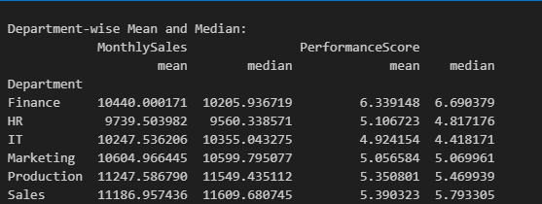

After that I visualized the department wise average using grouped bar charts
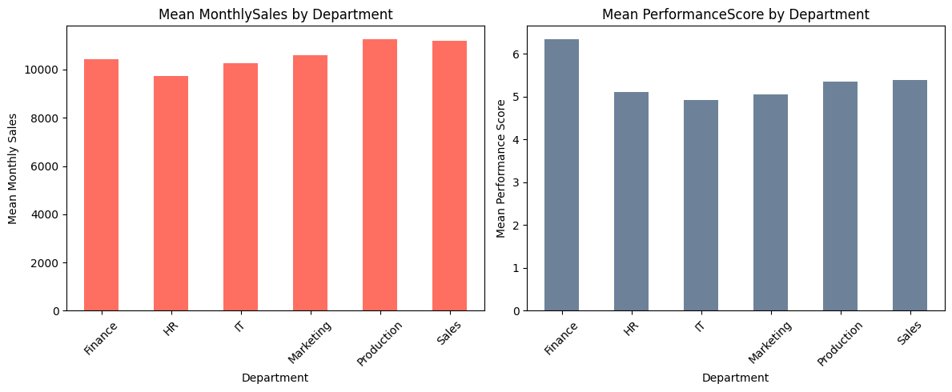

The combined heatmap is the
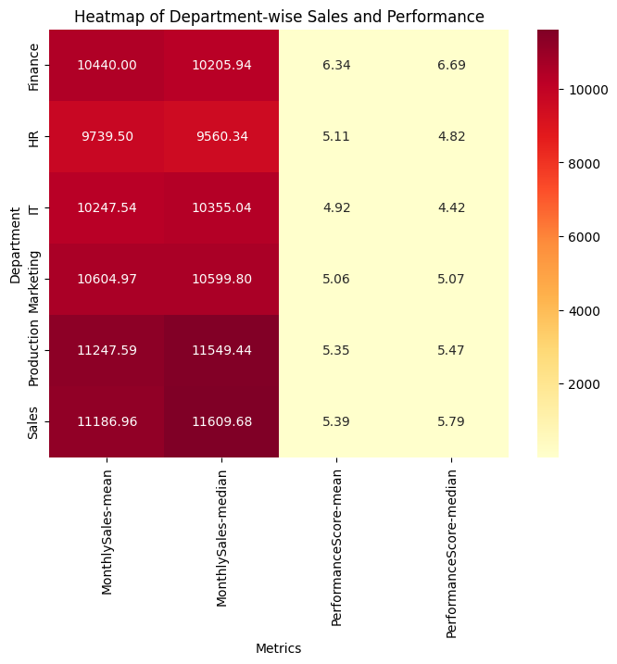
These values are consistent with the uniform distribution of the synthetic dataset and the earlier approximated values, confirming the heatmap accurately reflects the data.

After the analysis from the charts and values generated
Top-Performing Departments:
- Finance: Highest mean PerformanceScore (6.34), this department shows the strongest performance across departments.
- Production/Sales: Highest mean MonthlySales (11247.59/11186.96), this department shows the strongest sales performance.
Underperforming Departments:
- HR/IT: Lowest mean MonthlySales (9739.50/10247.54) and lowest mean PerformanceScore (5.11/4.92), this department shows a weaker performance and sales.

11. Top/Bottom employees

1. Top 5 Employees by MonthlySales
After the calculation for the ideantify the top employees by the monthly sales, The final calculated table is
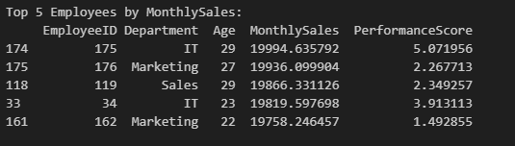
- Highest MonthlySales: 19994.635792 (EmployeeID 175, IT).
- Ages range from 22 to 29, with older employees (27-29) dominating the top sales.
- PerformanceScore is relatively low (1.49 to 5.07), with no strong correlation to sales.

2. Top 5 Employees by PerformanceScore
Calculation for the top 5 employees from the performance score is
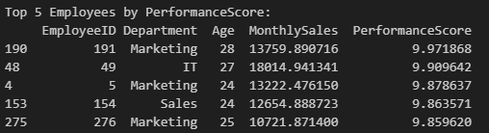
- Highest PerformanceScore: 9.971868 (EmployeeID 191, Marketing).
- Ages range from 24 to 28, with a mix of departments (Marketing is dominant with 3/5).
- MonthlySales varies widely (10721.87 to 18014.94), with no consistent high sales.

3. Comparison and Differences
- Top MonthlySales employees have high sales (19,000+) but low PerformanceScore (1.49 to 5.07),
e.g., EmployeeID 176 (19936.10, 2.27).
- Top PerformanceScore employees have high performance (9.86 to 9.97) but varied sales (10721.87 to 18014.94)
e.g., EmployeeID 191 (13759.89, 9.97).

Insight: This reinforces the earlier weak Pearson correlation (0.0654) between MonthlySales and PerformanceScore. It’s not indicating a strong relationship between the two metrics.

